How to Become a Colorectal Cancer Screening Champ!
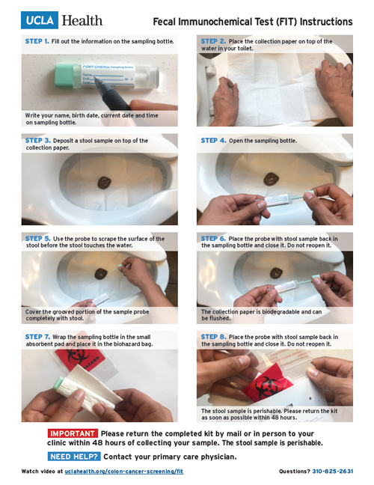

Tips to do while the patient is still in the office.
Open the package and explain the process with the patient:
- Keep this package where you most-often have a bowel movement. How often do you have a bowel movement? What time of day is that? Where is that? That’s where this kit needs to be stored. (No refrigeration is needed.)
- Get agreement to complete the test with the next bowel movement.
“I can probably expect this kit to be returned in (X) days.”
“I will follow-up in Y days to help you make sure you complete this important test.”
A) Update the phone number so you can call the patient for follow-up.
B) Update the mailing address in case a replacement kit needs to be mailed.
C) Pre-paid postage helps return rates.
D) Label the vial with the patient information: name and date of birth.
- “Poop on Demand” is a process where patients can complete this test before leaving the clinic.
- Open the package and explain the contents.
Paper
- This paper goes on the toilet water to keep your stool out of the water.
- Keep the stool away from any chemicals in the toilet water.
- If you put the paper down and then didn’t collect a specimen, that’s OK. There are other ways to collect the stool.
  - Scoot forward on an elongated toilet seat and have the stool fall onto the toilet bowl.
  - Put a substantial amount of toilet tissue into the bowl so the stool will sit on that toilet tissue.
  - Turn off the water to the toilet, flush the toilet, and collect the stool in a dry toilet bowl.
  - Otherwise, collect the specimen in a coffee can, yogurt container, ice cream bucket, etc. Collect the samples. Then flush the stool down the toilet.
  - Call me at 701-xxx-yyyy and I can mail you a new kit.
  - Write your name and phone number on the envelope in case the patient has questions.
How to collect the specimen:
- Remove this lid from the vial.
- See these grooves on the tip of this probe? That’s how far to insert this probe into the stool sample.
- Probe the stool sample in random places (per the manufacturer’s directions which may vary).
- Reinsert this probe into the vial.
- Gently shake the vial.
- Write the 1) date and 2) time of collection on the vial.
- Wrap the vial with the absorbent paper.
- Place the vial into the BioHazard Bag, insert the bag into the mailing envelope, and put it in the mail or deliver to the clinic.

Why do I need to complete this test?
Colon cancer is the cancer no one needs do die from but it’s the number 2 cause of cancer deaths in men and women combined.
Colon cancer screening saves lives.
This test looks for blood in your stool that might mean you have a growth called a “polyp” in your colon that could turn to cancer.
Polyps will bleed before they turn to cancer.
We hope to find these bleeding polyps or cancers early when they are easily removed.
If this test is positive for blood, we will look to see what is causing that blood loss.
The second test is a colonoscopy and polyps and small cancers can be cut out during that exam.

Thank you!
Thank the patient for collecting this test sample.
Thank the patient for calling with any questions.
Thank the patient for requesting a new kit, if needed.
Thank the patient for putting the sample into the mail by XXXX, as agreed.

When test samples are not returned.
Call the patient at the number provided to remind the patient or resolve any problems.

Nonadherent patients.
Many clinics are using Patient Navigators to help patients adhere to their treatment plans.
Patient Navigators can be assigned to ensure timely return of these test samples.
Use a tracking system to make sure all kits get returned.

Multi-target Stool DNA Test.
These kits include both the FIT test and a container to collect at least 30 grams of stool (one ounce med cup = 30 grams).
This test is an at-home stool test mailed to the patient’s home once a provider’s order is placed. (They also offer these kits by telemedicine.)
The patient mails the kit to the manufacturer.
The results are mailed to the provider.

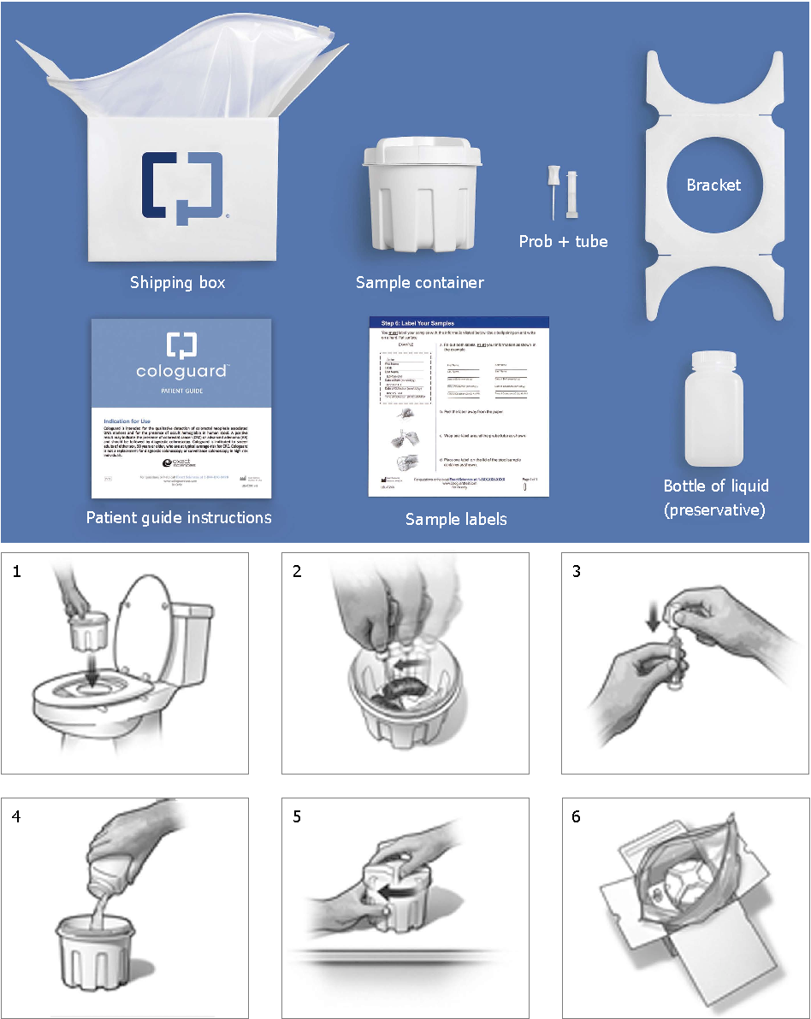
Clinics that do not have Patient Navigators may benefit from adopting the Multi-target Stool DNA test.
This product includes a Patient Navigator service which will call patients until they return the stool sample.
This test is completed every 3 years.
The company will call the patient until this kit gets returned. This company makes no money on tests that are not completed. They will make sure your patient returns this test.

Make Colorectal Cancer Screening your routine!
Any office visit is an opportunity to provide these stool test kits.

CRC Screening test intervals.
The CRC screening interval is test-dependent.
The right test is the test the patient will actually do.
FIT tests are done annually.
Multi-target Stool DNA tests are done every 3 years.
Screening Colonoscopies are done every 10 years.
Any positive stool test must be followed by a colonoscopy.

How to get those 2nd step-colonoscopies completed: Remove the barriers.
-Provide assistance with obtaining the preparation.
-Provide assistance with understanding how to do the preparation.
-Patients who tend to get nauseated might benefit from nausea medication.
-Patients who are constipated might need a few days on clear liquids or additional preparation.
-Refer to facilities that offer Patient Navigators to assist with the preparation.
-Arrange transportation to the colonoscopy facility (the sedation requires a driver be present.)
-Watch for the colonoscopy results. If they do not arrive, investigate the reason and reschedule patients who didn’t show for colonoscopy. Resolve the barrier they reported.

