Add Clinic Logo
Colorectal Cancer Screening and Documentation
Policy: Colorectal Cancer Screening and Documentation.
1) [Clinic Name] will utilize the USPSTF Colorectal Cancer Screening Guidelines to screen all eligible patients.
2) A standing order has been adopted which allows medical assistants and RNs with proper training to order a fecal immunochemical test (FIT) or Cologuard to screen for colorectal cancer for clients who meet the criteria for average risk clients. For clients found to be high risk, the provider will provide additional assessment and referral for colonoscopy.
Purpose: To improve colorectal cancer screening rates and surveillance at [Clinic Name]
Colorectal cancer often begins as polyps, which are small growths inside the lining of the colon. While most polyps are harmless, some may turn into cancer. Colorectal cancer is the second most common cancer found in men and women in the United States. The lifetime risk for developing colorectal cancer is roughly 1 in 20.
Screening and early detection saves lives. When colorectal cancer is diagnosed at the localized stage, the 5-year survival rate is 90%, with many people living much longer, and many cured. Unfortunately, only 39% of cases are diagnoses at this localized stage. If cancer is not detected until late stage, the 5-year survival rate drops to 14%.
Research shows that a recommendation from a health care provider is the most powerful single factor in a patient’s decision about whether to obtain cancer screening, specifically colorectal cancer, breast cancer and cervical cancer. In fact, lack of a doctor’s recommendation is actually experienced as a barrier to screening. Therefore, let this policy demonstrate that the health care providers serving this clinic believe so strongly in colorectal cancer screening that we assure, through a standing order, each and every client between the ages of 45 and 75 are offered this screening.
Source: National Colorectal Cancer Roundtable: https://nccrt.org

Procedure:
- Healthcare provider, Nurse or Medical Assistant identifies patient meeting screening eligibility for colorectal cancer using the screening algorithm.
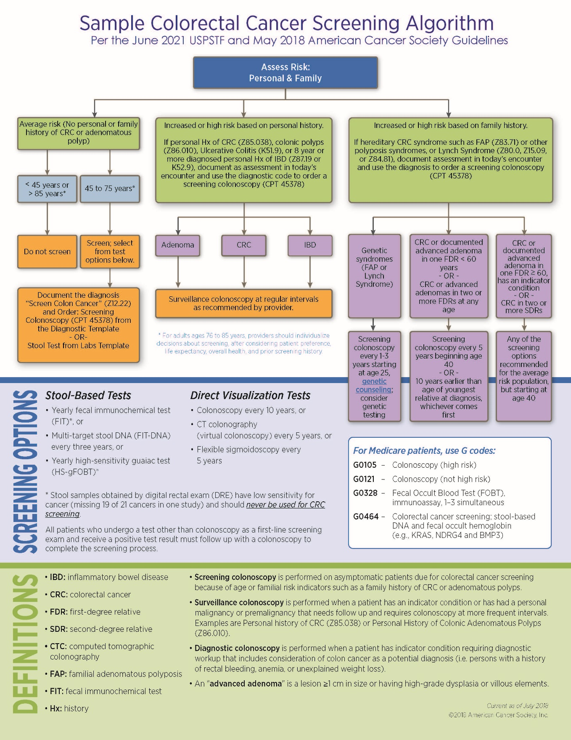
  - Average risk clients: Perform FIT/iFOBT test annually or Multi-target DNA (Cologuard®) every 3 years. If positive, diagnosis by colonoscopy
    - Clients aged 45-75 with no symptoms. (No change in bowel habits, no visual blood in stool, no dark or tarry stool)
    - No family history of colorectal cancer or adenomatous polyps
    - No colonoscopy in the last 10 years or FIT in the last year

  - High risk clients: Refer to provider for closer evaluation and colonoscopy
    - Clients with family history of colorectal cancer or adenomatous polyps diagnosed at age 60 or younger: screening colonoscopy starting at age 40 or 10 years younger than the earliest diagnosis in the family. Repeat screening colonoscopy every 5 years. (Consider additional testing such as genetic testing or additional cancer screening)
    - Personal history of Adenoma, CRC or Irritable Bowel Disease: Surveillance colonoscopy.
- Screen for contraindications
  - Active hemorrhoid bleeding—Wait until bleeding has stopped to perform test
  - Menstrual bleeding—Wait until bleeding has stopped to perform test
  - Short life expectancy or too frail to do colonoscopy—Check with clinician before screening
  - Symptoms suggesting colorectal cancer—Refer to clinician
- Order Appropriate Test
  - Stool Tests: FIT/iFOBT/Multi-target DNA (Cologuard®) test:
    - Provide client with test kit and written instructions in client’s preferred language
    - Review instructions on how to complete test with client
    - Explain diet or medication restrictions if necessary
      - FIT test: no diet or medication restrictions
      - iFOBT test: avoid for 3 days before the test: broccoli, turnips, red meat, horseradish, vitamin C supplements and pain relievers, such as aspirin, ibuprofen (Advil, Motrin, others)
      - Cologuard: no diet or medication restrictions
    - Explain procedure to return completed test kit to clinic or laboratory in postage stamped envelope provided for this purpose.
    - Close the loop: have client tell back the information, correct misinformation
  - Colonoscopy:
    - Provide client with written instructions for bowel prep and appointment information in the client’s preferred language.
    - Review instructions on how to complete the bowel prep.
      - Confirm colonoscopy date, location and time
      - Discuss arrangements for patient to get prep. Confirm specific pharmacy and when the patient will pick up the prep.
      - Address any transportation barriers.
      - Review prep instructions in detail, using the document the patient received in his or her primary language. Include items to have on hand for the day of prep, tips to make it easier, what to do if difficulties arise, and any barriers to following the instructions.
        - Explain the clear liquid diet with suggestions.
      - Assess understanding of prep by asking the patient to repeat back how they will complete the prep (TeachBack)
      - Offer link to YouTube prep video, Colonoscopy Prep: Tips and Tricks (www.youtube.com/watch?v=xd1N0WOcd5A). If the patient does not have Internet access, send a DVD if they have access to a DVD player.
      - Confirm patient has someone to accompany him/her to the procedure and reconfirm emergency contact.
- Record the reason(s) for non-receipt of the test [identify EMR location]
- If clients refuse testing, provide education and document.
- Document that kit was given to (FIT/iFOBT) or ordered (Cologuard) for client and date in client EMR.
- Document that FIT/iFOBT kit was given to client in tracking system
  - If FIT test is not returned within 2 weeks, activate the reminder system:
    - Client should be contacted with reminder letter at 2 weeks post visit
    - Client should be contacted with reminder letter at 4 weeks post visit
    - Client should be contacted with reminder phone call at 6 weeks post visit
[Suggested intervals: adapt as needed]
- Clinic staff will document all colorectal cancer screening (CRCS) tests in the electronic medical record (EMR) as a procedure code appropriate to the testing method used. [May choose to list the codes here. If multiple testing methods exist (FOBT, FIT) then more than one code may be required.]
- Upon return of test kit, document results in EMR [Identify location in the EMR]
- Enter CRCS due date into EMR as a deferred order when completed CRCS is documented.
[Clinic may choose to add billing procedure here]

Medical Director: ____________________________ ______________________________
Printed Name Signature

Effective Date:
Date Reviewed:
Date Revised:

